Transcript
(0:00) Hello and welcome! Today we are going to dive into the art of making the perfect cup of tea. It sounds simple, but there is a science to getting that perfect balance of flavor and aroma.
(0:12) First, let’s talk about the water. You should always start with fresh, cold water. Avoid re-boiling water that’s been sitting in the kettle, as it loses oxygen, which can make your tea taste flat.
(0:25) Now, the temperature is critical. For black tea, you want a rolling boil—about 212°F (100°C). However, if you're making green tea, boiling water will scald the leaves and make it bitter. For green tea, aim for around 175°F (80°C).
(0:45) Next up: the vessel. Pre-warm your teapot or mug by swirling a little hot water inside and then pouring it out. This ensures your tea stays at the right temperature during the brewing process.
(1:00) When it comes to the tea itself, use one teaspoon of loose-leaf tea per person, plus "one for the pot" if you're using a teapot. If you're using tea bags, one per mug is standard.
(1:15) Timing is everything. Set a timer! Black tea needs 3 to 5 minutes. Green tea is much quicker, usually 2 to 3 minutes. Herbal infusions can take up to 7 minutes to fully develop.
(1:30) Once the time is up, remove the tea leaves or the bag immediately. If you leave them in, the tea will become over-extracted and astringent.
(1:42) Finally, add your milk or sweetener if you like, but always taste the tea first to appreciate the natural profile. Pour, sip, and enjoy the perfect brew. Thanks for watching!
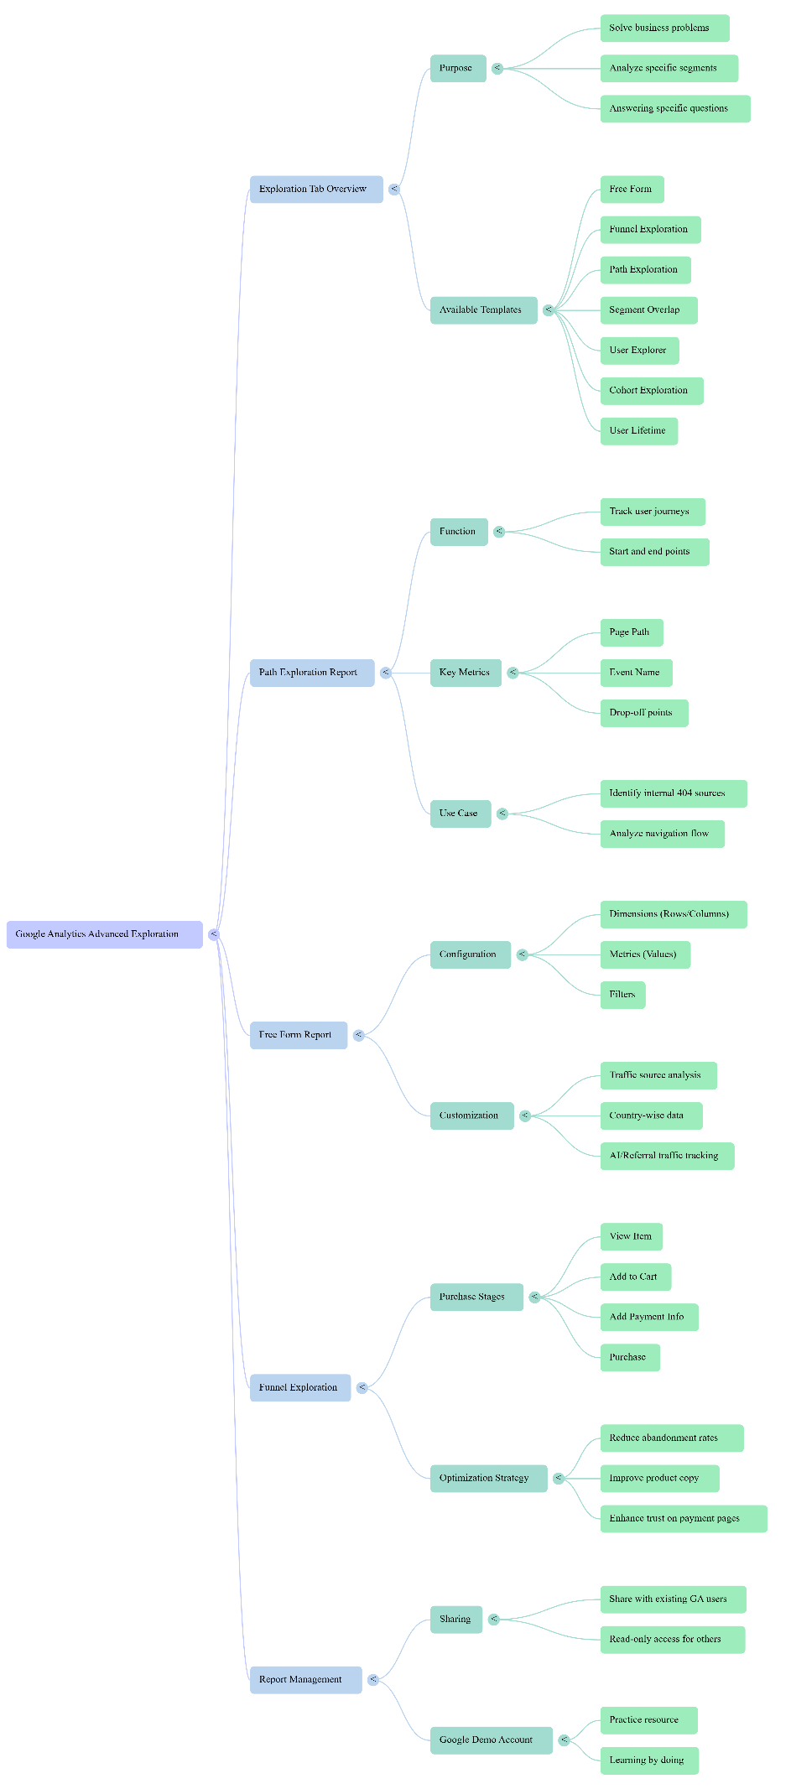
To effectively use the Exploration tab in Google Analytics, you should treat it as a tool where you bring a specific problem to find a tailored solution. The sources provide a detailed roadmap for navigating this section to optimize website performance and user experience.
Do's and Don'ts
• Do use the Google Analytics Demo Account: If you do not have enough data on your own property, practice using Google’s demo account to explore features without risk.
• Do practice actively: Simply watching tutorials is compared to "watching Netflix"; you must actually build reports to learn.
• Do name your reports clearly: Assign specific names like "Traffic Source Report" or "Stages of Purchase" to keep your explorations organized.
• Do select specific data: Because loading all server data can cause performance loss, manually choose the Dimensions and Metrics you need (e.g., Session source, Total users).
• Don't expect shared reports to be editable: When you share an exploration, other users can only view it; they cannot change filters or configurations.
• Don't confuse "Users" with "Page Views": When analyzing traffic, remember that "Total Users" refers to unique individuals, not the total number of times a page was loaded.
What Needs to be Done
The Exploration tab is designed for deep-dive analysis that standard reports cannot provide. You should:
• Identify user drop-off points: Determine exactly where users leave your site—whether it is after viewing a product or during the payment process.
• Track internal errors: Use reports to see if internal URLs are causing "404 Not Found" errors.
• Analyze specific segments: Look at how specific groups, such as users from certain countries or "Top Spenders," engage with your events and purchases.
How to Do It
1. Path Exploration:
◦ Click "Start Over" to define a Start Point (where the user began) or an End Point (the final page they reached, like a "Thank You" page).
◦ Select Page Path or Event Name to see the sequence of pages visited.
2. Free Form Reports:
◦ Dimensions: Add attributes like "Session source," "Country," or "Page location" to the Rows or Columns.
◦ Metrics: Add quantitative data like "Total users," "Sessions," or "Views" to the Values section.
◦ Filters: Apply conditions (e.g., "Session source contains Facebook") to narrow down your data.
3. Funnel Exploration:
◦ Define Steps based on the user journey (e.g., Step 1: View Item, Step 2: Add to Cart, Step 3: Purchase).
◦ Use the "pencil icon" to edit these steps and assign specific events to each.
Common Mistakes and Solutions
• Mistake: Conflicting Filters. Adding multiple "contains" filters for different sources (e.g., Facebook AND MSN) in a way that requires both to be true for a single session will result in "No Data".
◦ Solution: Ensure your filter logic allows for realistic data matches.
• Mistake: High Abandonment at Payment. Users reach the payment page but don't finish.
◦ Solution: This often indicates a lack of trust or technical issues. Add customer testimonials, user-generated content (UGC), or social proof to the payment page, and test the page speed and processor reliability.
• Mistake: High Drop-off at Product Pages. Users view products but do not add them to the cart.
◦ Solution: Improve your product copy, image quality, and technical details. Ensure you are using Schema data to attract a better-prepared audience from Google.
• Mistake: Mystery 404 Errors. High traffic to "Not Found" pages.
◦ Solution: Use Path Exploration with "Page Title" set to "Not Found" to identify which internal pages have broken links.

Transcript
(0:00) Hi everyone! Whether you’re writing a novel, a short story, or even just a personal journal, creative writing is a skill that takes practice. Today, I’m sharing five tips to help you take your writing to the next level.
(0:15) Tip 1: Show, Don’t Tell. This is the golden rule. Instead of saying "he was angry," describe his clenched fists, the heat rising in his neck, or the way he slammed the door. Let the reader feel the emotion through the action.
(0:38) Tip 2: Know Your Characters. Before you write a single word of your story, know your characters' secrets, their fears, and what they want most in the world. When you know them deeply, their dialogue and actions will feel authentic and natural.
(1:02) Tip 3: Use Sensory Details. Don’t just rely on sight. What does the air smell like after a rainstorm? How does the old wooden floor creak underfoot? Engaging all five senses grounds the reader in your world.
(1:25) Tip 4: Write Now, Edit Later. The biggest enemy of creativity is the internal critic. Just get the words down on the page. You can’t fix a blank page, but you can always fix a messy first draft later.
(1:48) Tip 5: Read Widely and Often. To be a great writer, you must be a great reader. Pay attention to how your favorite authors handle pacing, transitions, and character development. It’s the best "free" education you can get.
(2:10) Thanks for watching! Start practicing these today and watch your stories come to life. Happy writing!
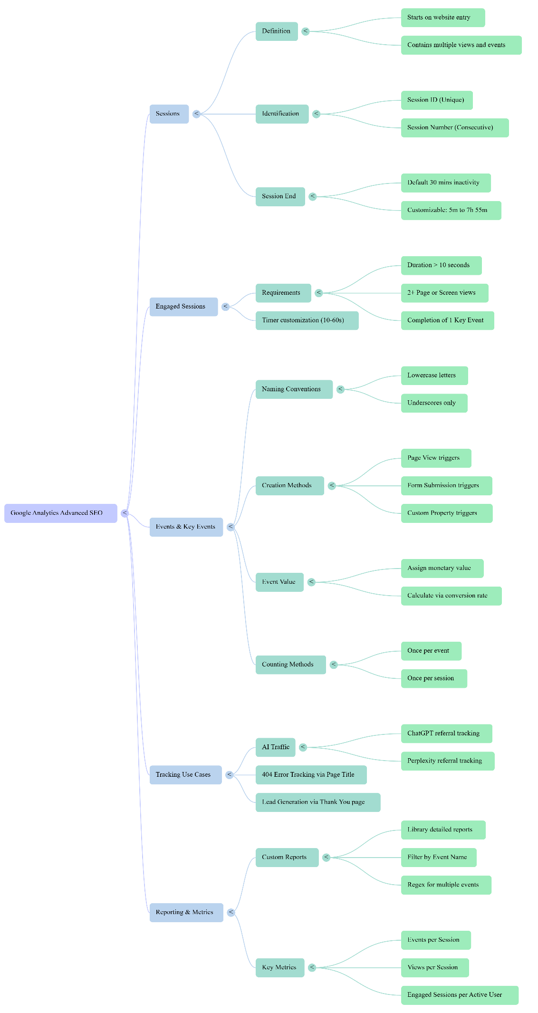

Do’s and Don’ts
• Do use correct naming conventions: When creating events, always use lowercase letters and underscores (e.g., thank_you_visit).
• Don't use capital letters or dashes: Google Analytics follows a specific nomenclature; using capitals or dashes in event names is against their standard practice.
• Do assign a value to Key Events: Even if it is just a nominal amount like $1 or ₹1, always assign a value to conversions so the system can calculate the business impact.
• Don't set a Key Event value to zero: Setting a value to zero prevents the Google system from understanding the reward or business generation resulting from a user action.
• Do customize session timeouts for specific content: For websites with long-form content like one-hour video lectures, increase the session timeout to prevent sessions from ending while a user is still engaged.
• Don't overload reports: It is recommended to keep reports simple by using a maximum of three metrics to ensure they remain easy to read and are not "hectic".
--------------------------------------------------------------------------------
What Needs to be Done & How to Do It
1. Customizing Session Settings
By default, Google Analytics ends a session after 30 minutes of inactivity.
• How to adjust: Navigate to Admin > Data Streams, select your stream, and go to Configure Tag Settings. Click "Show More" and select Adjust Session Timeout.
• Limits: You can set the timeout between a minimum of 5 minutes and a maximum of 7 hours and 55 minutes.
• Engaged Session Timer: You can also adjust the "Engaged Session" threshold from the default 10 seconds up to 60 seconds.
2. Creating and Tracking Events
Everything in Google Analytics is considered an "event," such as a click, scroll, or page view.
• Creating a Custom Event: Go to Admin > Data Display > Events > Create Event.
• Tracking AI Traffic (e.g., ChatGPT): Create an event where the parameter page_referrer contains "ChatGPT". This allows you to track how much traffic is coming from AI platforms.
• Tracking 404 Errors: Create an event where the page_title contains "404".
3. Building Custom Reports
• Step-by-Step: Go to the Reports section, enter the Library, and select Create Detailed Report followed by Blank.
• Customization: Add Dimensions (like Event Name or Page Path) and Metrics (like Total Users, Sessions, or Engaged Sessions).
• Pro Tip: Hide the bar chart initially to clear the workspace.
--------------------------------------------------------------------------------
Common Mistakes and Solutions
• Mistake: Inaccurate Lead Counting
◦ Problem: A single user might refresh a thank-you page or submit a form multiple times, inflating your lead count.
◦ Solution: Change the counting method from "Once per event" to "Once per session" to ensure a single user is only counted once per visit.
• Mistake: Failing to Demonstrate SEO Revenue
◦ Problem: SEO efforts often look like "traffic" rather than "money" to clients.
◦ Solution: Tie SEO to revenue by calculating the average lead value. For example, if 10% of leads convert into a ₹2000 service, set the lead value in Google Analytics to ₹200.
• Mistake: Session Fragmentation for Long-Form Content
◦ Problem: If a user watches a long video without clicking anything else, GA may mark them as inactive and end the session.
◦ Solution: Manually extend the session timeout in the settings to accommodate the length of your content.
• Mistake: Inability to Filter Multiple Events in One Report
◦ Problem: Users often struggle to show data for two different things (like ChatGPT and Perplexity traffic) in a single filtered report.
◦ Solution: Use the "Matches RegEx" filter and separate the event names with a pipe symbol (|), such as chat_gpt_traffic|perplexity_traffic.

